Geography as a Spatial Science: Concept of Space, Place, Region and Territory
Geography as a Spatial Science
Geography is often described as a spatial science because it studies the location, distribution, arrangement, and interaction of phenomena over the Earth’s surface. The spatial approach to geography is concerned not only with where things are located, but also with why they are located there, how they are distributed, and how different places are connected. Natural phenomena such as climate, vegetation, rivers, soils, and landforms, as well as human phenomena such as population, settlements, agriculture, industries, transportation, and economic activities, have particular spatial patterns. Geographers study these patterns to understand the processes responsible for their distribution and the relationships that exist among them.
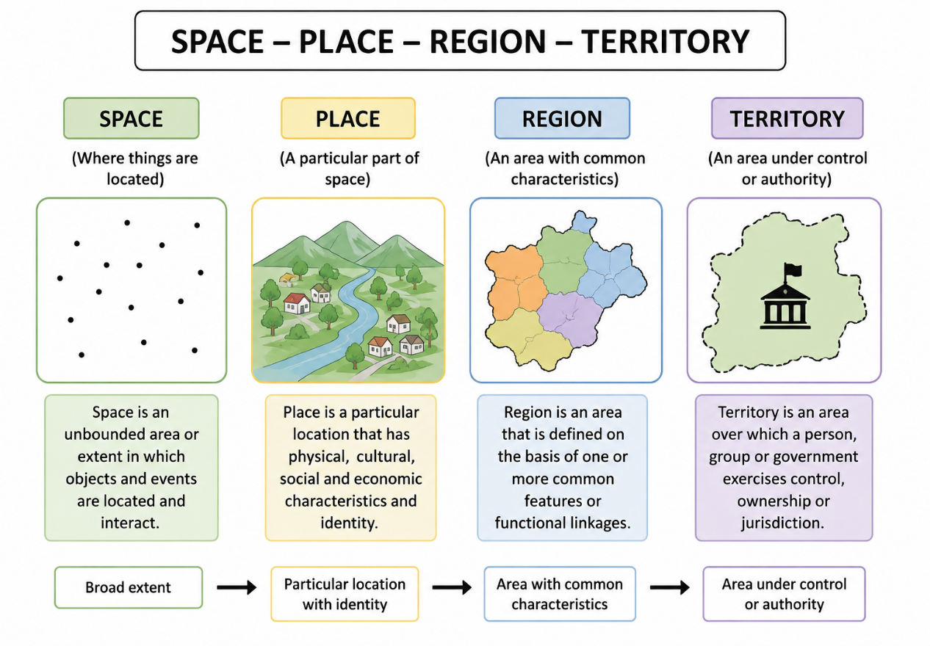
The development of geography as a spatial science became particularly important during the quantitative revolution of the 1950s and 1960s, when geographers increasingly adopted statistical methods, mathematical models, and spatial analysis. Scholars such as Fred K. Schaefer, William Bunge, and Peter Haggett contributed to the development of spatial approaches in geography. Instead of concentrating only on the description of individual regions, spatial geography sought to identify patterns, relationships, and general principles of spatial organization. Concepts such as location, distance, direction, distribution, density, accessibility, interaction, movement, and spatial association therefore became important in geographical analysis.
For example, the distribution of cities can be studied by examining their location, size, spacing, and connections through transportation networks. Similarly, the distribution of agricultural activities may be explained in relation to soil, rainfall, market accessibility, transportation costs, and population. Modern technologies such as Geographic Information Systems (GIS), Remote Sensing, Global Navigation Satellite Systems (GNSS/GPS), and spatial statistics have further strengthened geography as a spatial science by allowing geographers to map, measure, analyse, and model spatial patterns and relationships.
Concept of Space
Space is one of the most fundamental concepts in geography. In its simplest sense, geographic space refers to the area or extent of the Earth’s surface within which physical and human phenomena are located and interact. Everything studied in geography—mountains, rivers, settlements, roads, industries, populations, cultures, and economic activities—occupies space. Space therefore provides the spatial framework within which geographical processes and relationships can be examined.
Geographers commonly distinguish between absolute space and relative space. Absolute space refers to space as a fixed and measurable framework. Locations can be identified using latitude and longitude, while distance, area, and direction can be measured objectively. For example, Guwahati can be represented by its geographical coordinates, and the distance between Guwahati and Shillong can be measured in kilometres. In this sense, space exists independently of people's perceptions and can be represented accurately on maps.
Relative space, in contrast, is understood in terms of relationships between places rather than simply their physical distance. It may be expressed through travel time, transportation cost, accessibility, connectivity, or social interaction. For example, two villages may be only 20 kilometres apart in absolute distance, but poor roads and difficult terrain may make travel between them time-consuming. On the other hand, two distant cities connected by frequent air services may be relatively more accessible. Thus, relative space can change with improvements in transportation, communication, and technology.
Concept of Place
A place is a particular part of geographic space to which specific physical, social, cultural, or emotional characteristics are attached. While space is more general and abstract, place is space that has acquired identity and meaning. Every place has a particular location, but its geographical significance extends beyond its coordinates. Its landscape, people, culture, history, economic activities, and social relationships contribute to its distinctive character.
For example, Guwahati is not simply a location represented by latitude and longitude. It is also a place characterized by the Brahmaputra River, surrounding hills, urban settlements, transportation networks, religious and cultural sites, educational institutions, and the everyday experiences of its inhabitants. Similarly, a village may have special meaning for its residents because of their family relationships, traditions, memories, and attachment to the local landscape.
The concept of sense of place refers to the feelings, meanings, and attachments that individuals or communities associate with a particular location. Different people may therefore experience the same place differently. A forest, for example, may be regarded as a source of livelihood by one community, an ecological resource by conservationists, and a recreational landscape by tourists. Place is therefore both material and experiential, combining physical characteristics with human meanings and experiences.
Concept of Region
A region is an area of the Earth’s surface identified on the basis of one or more common characteristics or functional relationships. Regionalization helps geographers divide the Earth’s complex surface into meaningful spatial units for description, comparison, and analysis. Regions may be defined according to physical characteristics such as climate, relief, vegetation, and drainage, or according to human characteristics such as language, culture, economic activities, political systems, and settlement patterns.
Type of Region
A formal or homogeneous region is an area characterized by relative uniformity in one or more selected characteristics. For example, a climatic region may be identified on the basis of similar temperature and rainfall conditions, while a linguistic region may be identified by the predominance of a particular language. The boundaries of such regions are drawn according to the characteristics selected by the geographer.
A functional or nodal region is organized around a central point or node and is defined by interactions and flows between the centre and surrounding areas. A city and its commuting zone, for example, form a functional region because surrounding settlements are connected to the city through employment, transportation, trade, education, and services. Similarly, the service area of a major market or transportation hub may constitute a functional region.
A perceptual or vernacular region is based on people's perceptions, identities, and commonly held ideas about an area. Its boundaries are often less precise than those of administrative regions. For example, terms such as “Northeast India” may carry geographical as well as cultural and perceptual meanings. Thus, regions are not always naturally fixed units; they may be constructed differently depending on the criteria and purpose of geographical analysis.
Concept of Territory
Territory refers to a geographical area over which an individual, community, organization, or political authority exercises control, ownership, influence, or jurisdiction. Unlike the broader concept of space, territory emphasizes the relationship between space and power. A territory usually involves some form of boundary, whether clearly marked or socially recognized, separating an area controlled by one group or authority from another.
The most familiar example is the territory of a state or country, where a government exercises sovereignty within internationally recognized boundaries. Territory, however, can exist at several geographical scales. States, districts, municipalities, villages, tribal areas, and even local communities may exercise different forms of authority or control over particular areas. For example, the boundary of a state defines the geographical extent within which its government exercises administrative authority.
The related concept of territoriality refers to the attempt by individuals or groups to influence, control, organize, or defend a geographical area. Territoriality can be political, economic, social, or cultural. National borders represent political territoriality, while community control over common land or traditional resource areas represents territoriality at a local level. Territory is therefore an important geographical concept for understanding boundaries, sovereignty, governance, identity, conflict, resource control, and power relations.
Relationship between Space, Place, Region and Territory
The concepts of space, place, region, and territory are closely interconnected but emphasize different dimensions of geographical reality. Space provides the broad spatial framework within which phenomena are located and interact. Place refers to a particular part of that space that has distinctive characteristics, identity, and meaning. Region refers to an area grouped together because of common characteristics or functional relationships, while territory refers to an area associated with control, authority, ownership, or power. For example, a geographical area can be examined as space by studying its location and spatial relationships; as a place by examining its landscape, culture, and identity; as a region by identifying common physical or socioeconomic characteristics; and as a territory by examining boundaries, administration, and control. Together, these concepts provide a fundamental framework for understanding the spatial organization of both physical and human phenomena on the Earth’s surface.
Geographic Space: Absolute and Relative
Geographic space refers to the physical and human environment in which geographical features, activities, and relationships exist. It includes natural features such as mountains, rivers, climate, and vegetation, as well as human features such as settlements, roads, industries, and cultural landscapes. Geographers commonly understand geographic space in terms of absolute space and relative space.
Absolute space refers to a fixed and measurable location on the Earth’s surface, usually expressed through coordinates, distance, area, or boundaries. For example, Guwahati can be located at approximately 26.1° N latitude and 91.7° E longitude, while the distance between two places can be measured objectively in kilometres. In this sense, space exists as a physical framework that can be mapped and measured.
Relative space, on the other hand, refers to space understood in relation to other places, particularly through factors such as travel time, accessibility, cost, connectivity, and social interaction. For example, two villages may be only 20 km apart in absolute distance, but if they are separated by hilly terrain and poor roads, travelling between them may take several hours. Conversely, Guwahati and Delhi are geographically far apart, but air transport and digital communication make them relatively more connected. Thus, while absolute space emphasizes fixed location and measurable distance, relative space emphasizes relationships, accessibility, and the way distance is experienced or overcome through transportation, technology, and human interaction.

Spatial Concepts: Questions and Answers
1. What is geographic space?
Answer: Geographic space is the spatial area or dimension in which physical and human phenomena are located, distributed, and interact.
2. What is absolute space?
Answer: Absolute space is a fixed and measurable space in which locations have precise positions.
3. What is relative space?
Answer: Relative space refers to space understood in terms of relationships such as distance, accessibility, connectivity, and interaction.
4. Give one example of absolute space.
Answer: The geographical coordinates of a place, such as 26°10′N, 91°45′E, are an example of absolute space.
5. Give one example of relative space.
Answer: A village located 30 minutes from a town by road is an example of relative space.
6. Which type of space refers to a fixed and measurable location?
Answer: Absolute space.
7. Which type of space is influenced by accessibility and connectivity?
Answer: Relative space.
8. What is absolute location?
Answer: Absolute location is the exact position of a place on the Earth's surface, usually expressed using coordinates.
9. Name one method used to express absolute location.
Answer: Latitude and longitude.
10. How is absolute distance generally measured?
Answer: Absolute distance is generally measured in standard units such as kilometres or metres.
11. Mention one factor that influences relative space.
Answer: Transportation is one factor that influences relative space.
12. How does transportation influence relative space?
Answer: Improved transportation reduces travel time and increases accessibility between places, making them relatively closer.
13. Can relative space change over time?
Answer: Yes. Relative space can change due to changes in transportation, technology, accessibility, and communication.
14. What is meant by spatial science in geography?
Answer: Spatial science is the study of the location, distribution, pattern, and spatial relationships of geographical phenomena.
15. Define geographic space.
Answer: Geographic space is the spatial framework in which geographical phenomena occur and interact.
16. What is absolute space?
Answer: Absolute space is a fixed, measurable, and objective space in which locations can be precisely identified.
17. What is relative space?
Answer: Relative space is space defined by relationships between places, particularly in terms of distance, accessibility, and connectivity.
18. What is meant by absolute location?
Answer: Absolute location is the precise geographical position of a place, expressed through coordinates such as latitude and longitude.
19. Give one example of absolute space.
Answer: The exact latitude and longitude of Guwahati is an example of absolute space.
20. Give one example of relative space.
Answer: Saying that Guwahati is about a few hours from Shillong by road represents relative space.
21. What is meant by place in geography?
Answer: Place refers to a specific location along with its physical characteristics, human characteristics, and meanings.
22. What is meant by sense of place?
Answer: Sense of place refers to the feelings, meanings, experiences, and attachments people associate with a particular place.
23. Mention one characteristic that gives identity to a place.
Answer: Cultural characteristics give identity to a place.
24. Define a region.
Answer: A region is an area that shares one or more common characteristics or has a particular spatial organization.
25. What is a formal region?
Answer: A formal region is an area characterized by one or more uniform or common features.
26. What is a functional region?
Answer: A functional region is an area organized around a central node or focal point, connected by flows and interactions.
27. Give one example of a formal region.
Answer: The tea-growing region of Assam is an example of a formal region.
28. Give one example of a functional region.
Answer: The service area of a city is an example of a functional region.
29. What is a perceptual region?
Answer: A perceptual region is an area identified by people's perceptions, beliefs, or shared ideas about it.
30. What is meant by regionalization?
Answer: Regionalization is the process of dividing or organizing geographic space into regions based on selected characteristics.
31. Define territory.
Answer: Territory is a defined area of geographic space that is controlled or claimed by an individual, group, or state.
32. What is territoriality?
Answer: Territoriality is the attempt to control, influence, or defend a particular area of space.
33. Mention one element that distinguishes territory from space.
Answer: Control or ownership distinguishes territory from general space.
34. What is meant by a territorial boundary?
Answer: A territorial boundary is a line or limit that defines the extent of control over a territory.
35. Name one geographical concept associated with political control over space.
Answer: Territory.
36. State one difference between space and place.
Answer: Space refers to the spatial dimension or area, whereas place refers to a specific location with characteristics and meaning.
37. State one difference between region and territory.
Answer: A region is identified by common characteristics or functional relationships, whereas a territory is defined by control or authority over an area.
38. How does a place differ from a location?
Answer: Location identifies where something is, whereas place includes the characteristics, experiences, and meanings associated with that location.
39. Which geographical concept refers to an area under the control of an individual, group, or state?
Answer: Territory.
40. Which type of region is organized around a central node?
Answer: Functional region.
41. Which type of region is characterized by uniform or common features?
Answer: Formal region.
42. Which concept emphasizes the uniqueness and meaning attached to a location?
Answer: Place.
Four Key Spatial Concepts
The four key spatial concepts in geography are:
- Space – the spatial dimension in which geographical phenomena exist and interact.
- Place – a specific location with distinctive physical, human, and cultural characteristics.
- Region – an area identified by common characteristics or functional relationships.
Territory – an area associated with control, authority, or ownership.
6-Mark Questions and Answers
1. Explain the concepts of absolute space and relative space in geography.
Answer:
Space is an important concept in geography and can be understood as absolute space and relative space.
Absolute space refers to a fixed, measurable and objective space. Every location has a definite position that can be identified using geographical coordinates such as latitude and longitude. Distance in absolute space is usually measured in standard units such as kilometres or metres. For example, the exact geographical coordinates of Guwahati represent absolute location.
Relative space refers to the relationship between two or more places based on their accessibility, connectivity, travel time, transportation and distance. Unlike absolute space, relative space is not simply concerned with the exact physical distance between places. It considers how easily or quickly one place can be reached from another. For example, suppose a village is 20 km away from a town. If the village has a good road and regular transport, people may reach the town in only 30 minutes, so the village is relatively close to the town. However, if the road is poor and transportation is limited, the same 20 km journey may take two hours, making the village relatively farther away. Therefore, relative space can change when transportation, communication or accessibility improves, even though the actual physical distance between the places remains the same.
Thus, absolute space emphasizes fixed location and measurable distance, while relative space emphasizes accessibility, connectivity and relationships between places.
2. Explain the geographical concepts of place, region and territory.
Answer: Place, region and territory are important concepts used to understand the organization of geographical space.
Place refers to a specific location having distinctive physical, social, cultural and economic characteristics. It also includes the meanings and feelings that people attach to a location. This is known as the sense of place.
Region is an area that has certain common characteristics or functional relationships. A formal region is characterized by uniform features, such as a tea-growing region. A functional region is organized around a central node, such as the service area of a city. A perceptual region is based on people's perceptions and beliefs.
Territory is a defined area over which an individual, group, organization or state exercises control or claims authority. Territoriality refers to the process of controlling or defending a particular area.
Thus, place emphasizes identity and meaning, region emphasizes common characteristics or spatial relationships, and territory emphasizes control and authority over space.

