Fourier Transform Infrared (FTIR) spectroscopy
Fourier Transform Infrared (FTIR) spectroscopy is the preferred method of infrared spectroscopy. IR radiation is transmitted through a sample in infrared spectroscopy. The sample absorbs some of the infrared energy, and some of it is transferred (passed through). The resulting spectrum gives the sample a molecular fingerprint by displaying the molecule’s absorption and transmission. No two unique molecule configurations produce the same infrared spectrum, just like fingerprints. As a result, infrared spectroscopy is useful for a variety of analyses.
Principle:
- FT-IR always relies on the fact that the most molecules absorb light in the infra-red region of the electromagnetic spectrum.
- This absorption corresponds specifically to the binds present in the molecule of the analyte. The frequency range is commonly measured using wave numbers ranging from 4000-600cm⁻¹.
- Firstly, the background emission spectrum of the IR source is recorded, followed by the emission spectrum of the IR source with the sample in place.
- The ratio of the sample spectrum to the background spectrum is proportional to the sample’s spectrum absorption.
- The resultant absorption spectra from the bond natural vibration frequencies indicates that the sample has a variety of chemical bonds and functional groups.
- Because of the variety of functional groups, side chains, and cross-links involved, FTIR is especially useful for identifying organic molecular groups and compounds, all of which have distinct infrared vibrational frequencies.

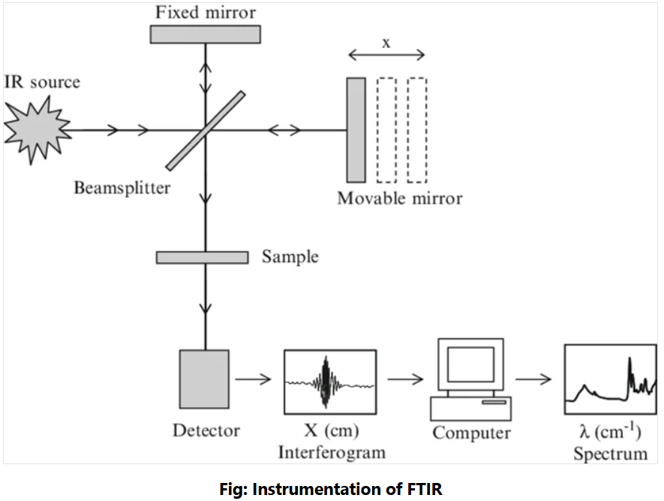
Different parts of FTIR instrumentation include:
The Source: A broadband emitter, such as a mid-IR ceramic source, a far-infrared mercury lamp, or a near-infrared halogen lamp, is used as the light source.
The Interferometer
The interferometer, which consists of a beamsplitter, a stationary mirror, and a moving mirror, is the heart of an FTIR spectrometer. The beamsplitter is a semi-transparent mirror that divides a collimated light beam into two optical channels. Half of the light is transferred to the moving mirror and half is reflected to the stationary mirror. The moving and stationary mirrors reflect the two light beams, which are recombined at the beamsplitter before going through the sample chamber and onto the detector.
The sample
Depending on the type of analysis being performed, the beam enters the sample compartment and is either transmitted through or reflected off the surface of the sample. This is where certain frequencies of energy that are unique to the sample are absorbed.
Detector
FTIR detectors are used to measure and convert the transmitted or reflected light from a sample into an electrical signal. The sensitivity and wavelength range of the data that can be captured is determined by the type and material of the detector.
The detector converts the beam into photons, which are then translated into measurable electric signals that the computer can read. The following are some examples of common detectors:
- Room temperature DLATGS is a regular analysis tool.
- Cooled liquid nitrogen is employed in sensitive applications.
- Si-photodiodes are employed in near-IR and visible infrared applications.
- Silicon far-infrared bolometers
Applications of FTIR
- FTIR spectroscopy equipment is commonly used to examine industrially manufactured materials in various quality control processes.
- FTIR spectroscopy is a common first step in material analysis. A change in the spectrometer’s absorption band characteristic patterns suggests a change in the material composition or possible contamination.
- It is used to dry polymers, photoresist materials, and polyimides.
- FTIR spectroscopy investigates the interactions between matter and electromagnetic radiation, which appear as a spectrum.
- FTIR spectrum analysis has enabled the diagnosis of various organ diseases as well as the quantification of various biomolecules such as proteins, nucleic acids, and lipids.
- FTIR is a unique approach for characterizing the variation in fuel stability of several biodiesel /antioxidant mixtures.
- In most failure analysis investigations, it is used to determine breakdown, oxidation, and uncured monomers.
- FTIR is also used for :
- high-resolution experiments
- trace analysis in raw materials or final products.
- Reactions on the microsecond time scale.
- Chromatographic and thermogravimetric sample fraction analysis.
- It is used to identify reaction components and conduct kinetic studies on reactions.
- It is used for compound identification by matching the spectra of an unknown substance with a reference spectrum (fingerprinting).
- It is also utilized for functional group identification in unknown compounds. For example, Ketones, Aldehydes, Carboxylic Acids, and so on.

