Nuclear magnetic resonance spectroscopy
Nuclear magnetic resonance spectroscopy, most commonly known as NMR spectroscopy or magnetic resonance spectroscopy (MRS), is a spectroscopic technique to observe local magnetic fields around atomic nuclei. It is a spectroscopy technique that is based on the absorption of electromagnetic radiation in the radiofrequency region 4 to 900 MHz by nuclei of the atoms. Over the past fifty years, NMR has become the preeminent technique for determining the structure of organic compounds. Of all the spectroscopic methods, it is the only one for which a complete analysis and interpretation of the entire spectrum is normally expected.
Principle of Nuclear Magnetic Resonance (NMR) Spectroscopy
Nuclear Magnetic Resonance (NMR) relies on several fundamental principles that underlie its capacity to analyze the magnetic properties of atomic nuclei. The core concept of NMR is based on the interaction between atomic nuclei and an external magnetic field, which can be summarized in the following key points:
- Magnetic Properties of Nuclei: Certain atomic nuclei possess a property known as spin, which gives rise to a magnetic moment. For instance, nuclei like ¹H (proton) and ¹³C (carbon) have non-zero spins and are commonly studied using NMR.
- Application of External Magnetic Field: When placed in a strong external magnetic field, these nuclei align with or against the field. This results in two energy states: a lower-energy state, where the nucleus aligns with the field, and a higher-energy state, where it aligns against the field.
- Resonance Condition: NMR occurs when a radiofrequency pulse is applied at the appropriate frequency, known as the resonance frequency, which corresponds to the energy difference between the two states. This causes the nuclei to transition from the lower to the higher energy state.
- Signal Detection: After the radiofrequency pulse is turned off, the nuclei relax back to their original state, releasing energy in the form of radio waves. This emitted signal is detected by the NMR instrument and is analyzed to obtain information about the chemical environment of the nuclei.
Moreover, NMR spectroscopy is influenced by additional factors that enhance its analytical power:
- Chemical Shift: Variations in the electronic environment surrounding the nuclei lead to shifts in their resonance frequencies, providing vital information about the molecular structure. This phenomenon is quantified in parts per million (ppm), which is a fundamental aspect of interpreting NMR spectra.
- Spin-Spin Coupling: The interaction between neighboring nuclei, known as J-coupling, results in splitting of NMR signals into multiplets. This allows chemists to glean insights into the number of adjacent atoms and their spatial relationships within a molecule.

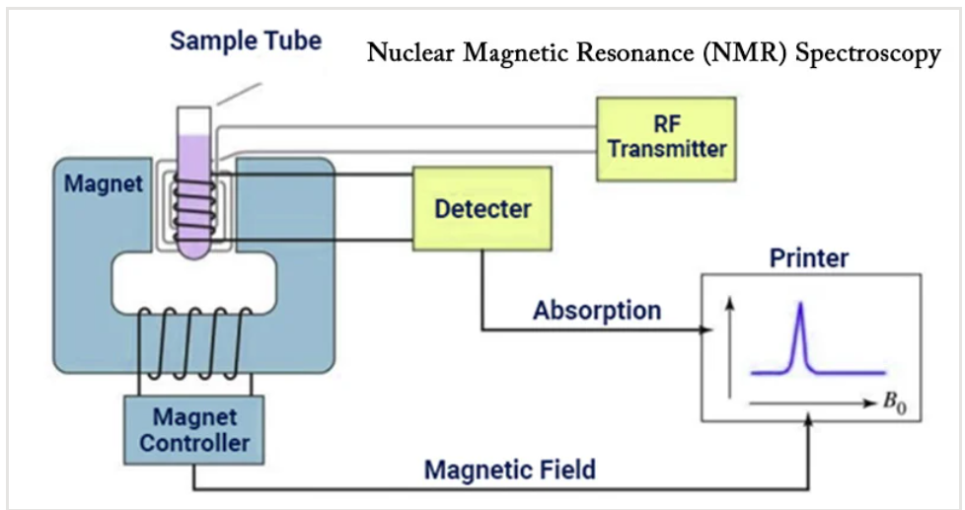
Working of Nuclear Magnetic Resonance (NMR) Spectroscopy
- The sample is placed in a magnetic field and the NMR signal is produced by excitation of the nuclei sample with radio waves into nuclear magnetic resonance, which is detected with sensitive radio receivers.
- The intramolecular magnetic field around an atom in a molecule changes the resonance frequency, thus giving access to details of the electronic structure of a molecule and its individual functional groups.
- As the fields are unique or highly characteristic to individual compounds, NMR spectroscopy is the definitive method to identify monomolecular organic compounds.
- Besides identification, NMR spectroscopy provides detailed information about the structure, dynamics, reaction state, and chemical environment of molecules.
- The most common types of NMR are proton and carbon-13 NMR spectroscopy, but it is applicable to any kind of sample that contains nuclei possessing spin.
Instrumentation of Nuclear Magnetic Resonance (NMR) Spectroscopy
- Sample holder
Glass tube with 8.5 cm long, 0.3 cm in diameter.
- Permanent magnet
It provides a homogeneous magnetic field at 60-100 MHZ
- Magnetic coils
These coils induce a magnetic field when current flows through them
- Sweep generator
To produce an equal amount of magnetic field pass through the sample
- Radio frequency transmitter
A radio transmitter coil transmitter that produces a short powerful pulse of radio waves
- Radio frequency receiver
A radio receiver coil that detects radio frequencies emitted as nuclei relax to a lower energy level
- Read out systems
A computer that analyses and records the data.
Applications of Nuclear Magnetic Resonance (NMR) Spectroscopy
Spectroscopy is the study of the interaction of electromagnetic radiation with matter. NMR spectroscopy is the use of the NMR phenomenon to study the physical, chemical, and biological properties of matter.
- It is an analytical chemistry technique used in quality control.
- It is used in research for determining the content and purity of a sample as well as its molecular structure. For example, NMR can quantitatively analyze mixtures containing known compounds.
- NMR spectroscopy is routinely used by chemists to study chemical structure using simple one-dimensional techniques. Two-dimensional techniques are used to determine the structure of more complicated molecules.
- These techniques are replacing x-ray crystallography for the determination of protein structure.
- Time domain NMR spectroscopy techniques are used to probe molecular dynamics in solution.
- Solid state NMR spectroscopy is used to determine the molecular structure of solids.
- Other scientists have developed NMR methods-of measuring diffusion coefficients.

